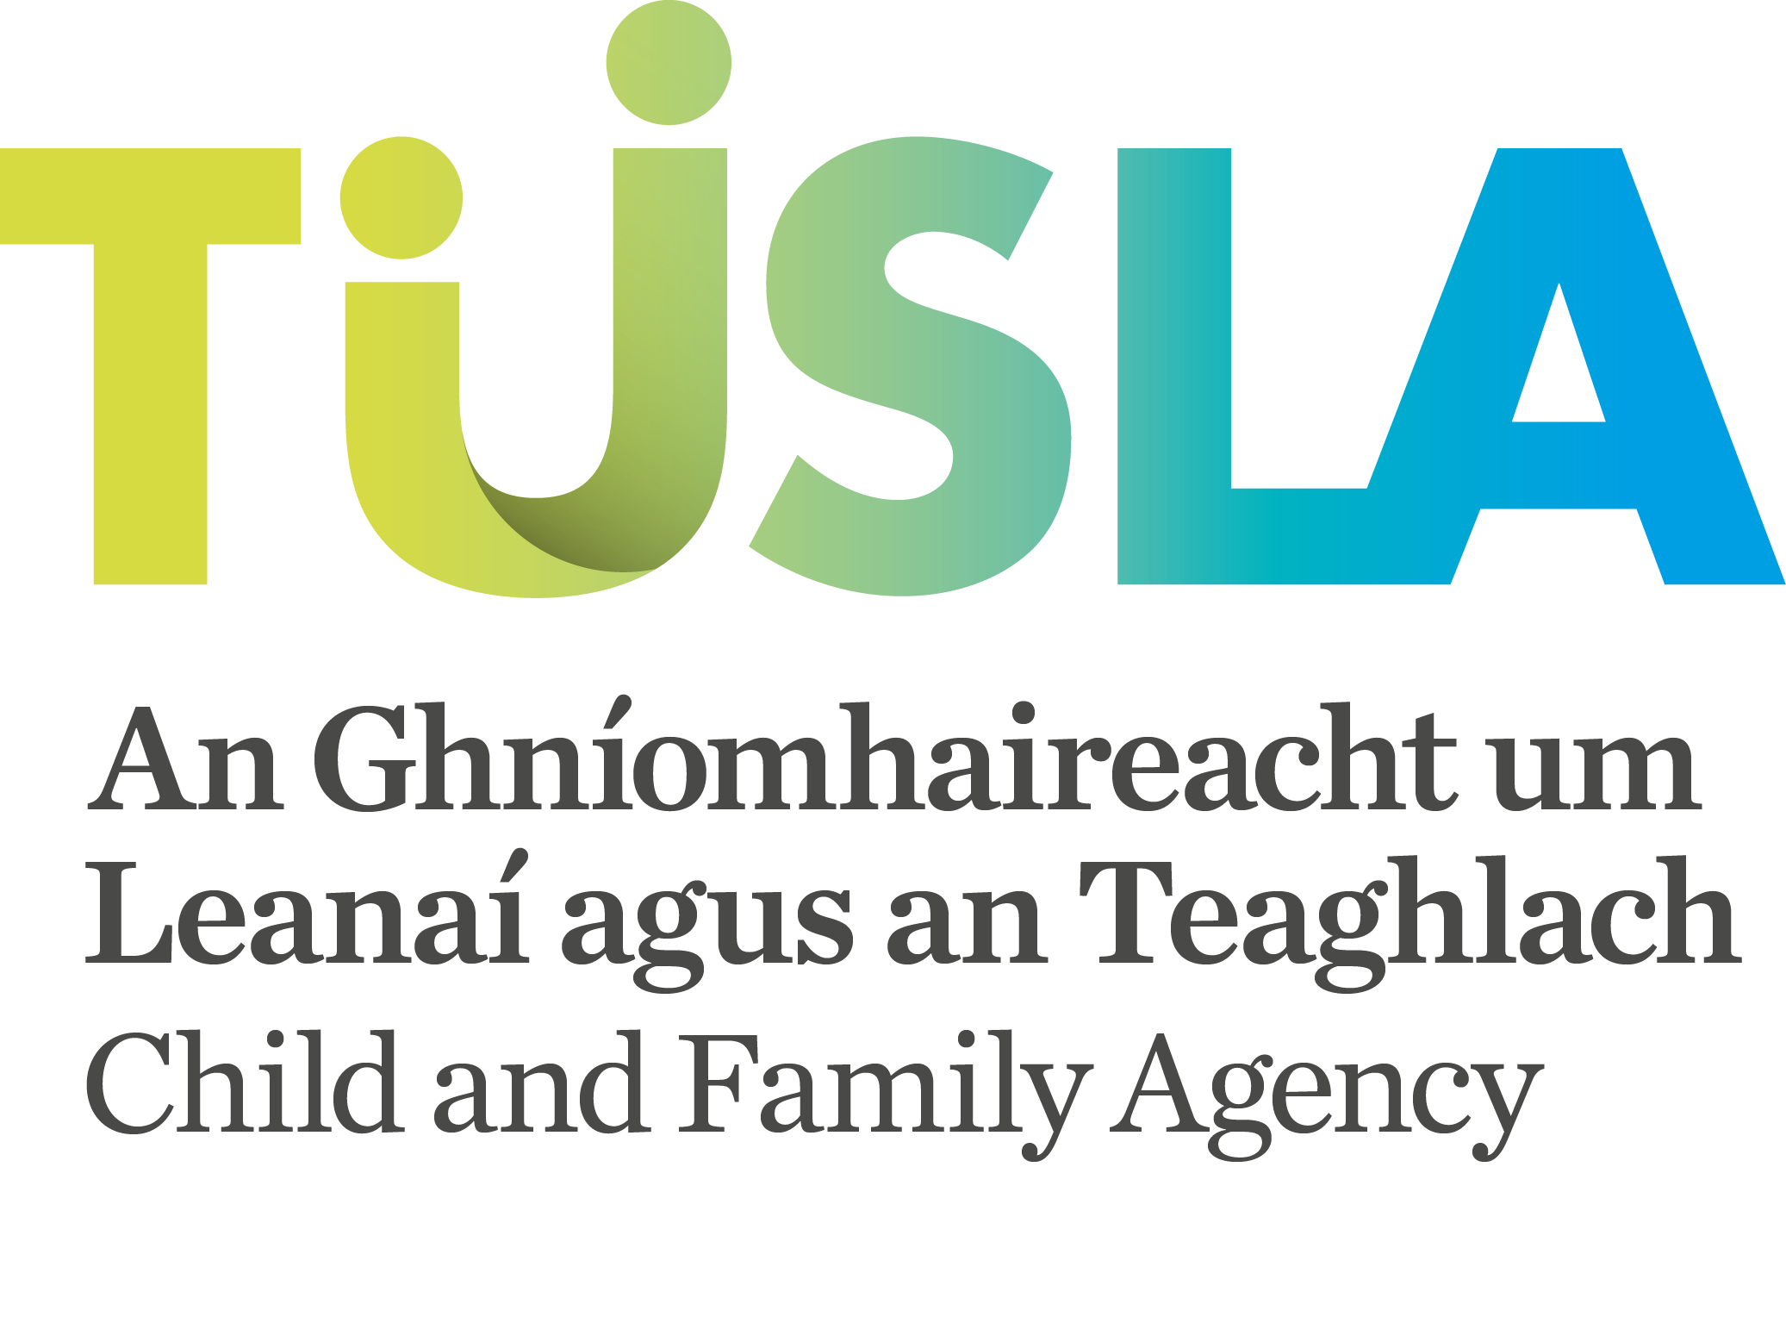

TOWARDS A SHARED PURPOSE

Review Sheet

- What are your views on the stated purpose (as set out on page 14)?

Please score from 1 (low) to 10 (high)
1 | 2 | 3 | 4 | 5 | 6 | 7 | 8 | 9 | 10

- What are your views on the values (as set out on page 14)?

Please score from 1 (low) to 10 (high)
1 | 2 | 3 | 4 | 5 | 6 | 7 | 8 | 9 | 10
- What are your views on the vision (as set out on page 15)?

Please score from 1 (low) to 10 (high)
1 | 2 | 3 | 4 | 5 | 6 | 7 | 8 | 9 | 10

- What are your views on the focused areas of work (as set out on page 15)?

Please score from 1 (low) to 10 (high)
1 | 2 | 3 | 4 | 5 | 6 | 7 | 8 | 9 | 10

- What are your views on the criteria for deciding key Strategic Action (as set out on page 16)?

Please score from 1 (low) to 10 (high)
1 | 2 | 3 | 4 | 5 | 6 | 7 | 8 | 9 | 10
- What are your views on the proposed key Purpose Statements (as set out on page 17)?

Please score from 1 (low) to 10 (high)
1 | 2 | 3 | 4 | 5 | 6 | 7 | 8 | 9 | 10

- What are your view of the overall structure for the Agency’s emerging priorities?

Please score from 1 (low) to 10 (high)
1 | 2 | 3 | 4 | 5 | 6 | 7 | 8 | 9 | 10

General Comments:

Please return your completed questionnaire to;

emma.dodrill@tusla.ie

Emma Dodrill,
Child and Family Agency,
4th Floor,
St Stephen's Green House,
Earlsfort Terrace,
Dublin 2.

Thank you.

Submitted By
Name:

Organisation:

Contact:

