

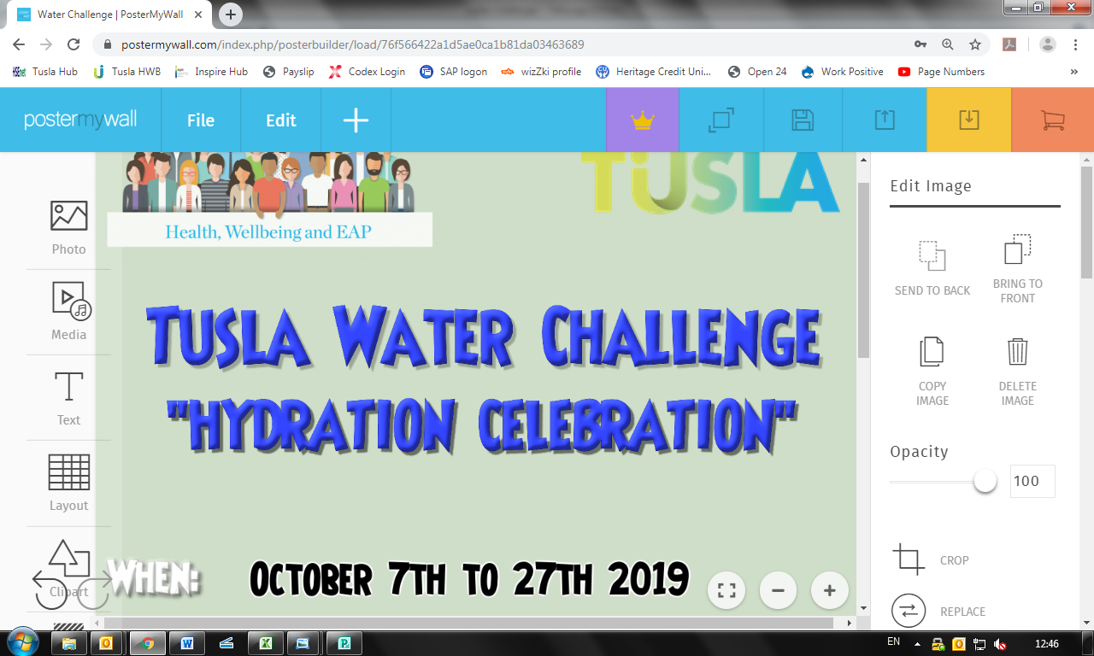

Week Ending: __________________________________

|  |  |  |
| --- | --- | --- |
| **Day** | **Amount You Drank (mls)** | **Total for the Week**  **(mls)** |
| Monday |  |  |
| Tuesday |  |
| Wednesday |  |
| Thursday |  |
| Friday |  |
| Saturday |  |
| Sunday |  |

