

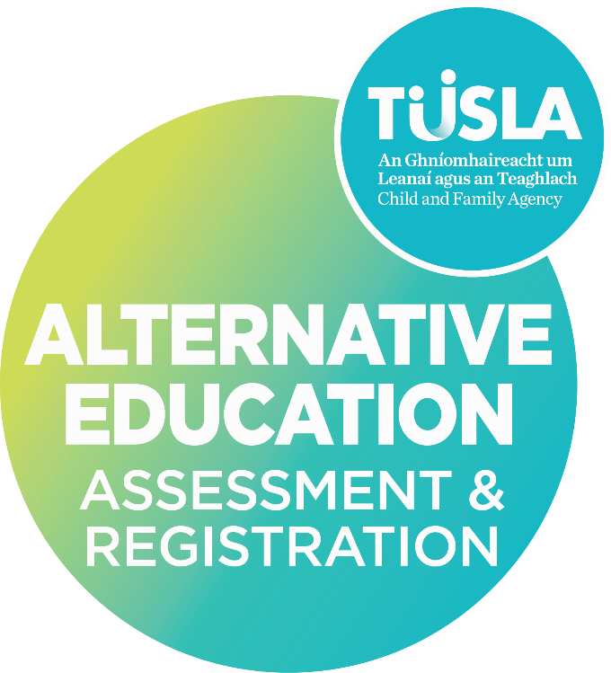
R2 SUPPLEMENTARY Information Form for an Independent School/Programme of Education
For children in receipt of an education in a place other than a recognised school under Section 14 of the Education (Welfare) Act 2000.

[SCHOOL NAME] [Academic Year]

[Academic Year]

[Academic Year]

Table of Contents

Section 1 - School Information 2
Section 1.1 General Information Updates 2
Section 1.2 School Governance 3
Section 1.3 School Staff Updates 3
Section 2. Safeguarding and Welfare Updates 4
Section 2.1 – Garda Vetting 4
Section 2.2 – Child Protection and Welfare Updates 5
Section 3. Premises and Safety Updates 5
Section 3.1 – Changes to Premises 5
Section 3.2 – Water Supply 6
Section 3.3 – Health and Safety 7
Section 3.4 – Insurance Arrangements 7
Section 3.5 – Fire Safety 7
Section 3.6 – Food Preparation 8
Section 4. Education Provision 8
Section 5. Children Enrolled 9
Section 5.1 – Number of Children Enrolled Update 9
Section 5.2 – Confirmation of Names, New Enrolments/Children enrolled now under section 14 of the Education (Welfare) Act, 2000, and Children that have left the school during the academic year. 9
Section 6. R2 Supplementary Form Completion – Checklist 9
Section 7. Principals Signed Declaration 10

This R2 Form is to provide UPDATED information for changes during an academic year and is used to supplement the information provided in the R2 Information provided previously. You are only required to complete sections as relevant. The R2 supplementary form should be returned to the Alternative Education Assessment and Registration Service by email independent.schools@tusla.ie

Section 1 - School Information

Section 1.1 General Information Updates

School Details
There has been a change to the School Details ☐ Yes
If YES, please indicate the change below and provided the updated details in the relevant section

Change of School Name ☐

Change of School Type ☐

Change of Contact person for R2 Forms ☐

Change of Associated Services ☐

Change of Name of School/Programme of Education | Click or tap here to enter text. |  | If known by another name | Click or tap here to enter text.
Change of Address of School Premises |  |  | Administrative Address (if different)
Eircode | Click or tap here to enter text. |  | Telephone (include local code) | Click or tap here to enter text.
School mobile if available | Click or tap here to enter text. |  | E-mail | Click or tap here to enter text.
Change of person nominated to contact regarding the R2 Information Form | Name:  Role: |  | Change of Contact Details for nominated person | Email:  Telephone:
Change of School Type (tick all relevant boxes)
Primary | ☐ |  | Primary and Post Primary | ☐
Post Primary | ☐ |  | Transition Year Programme | ☐
Day School | ☐ |  | Boarding School | ☐
Total Number of Children Enrolled |  |  | Number of Children enrolled boarding at school
Change of Associated Services or Educational Provisions
Does the school provide a breakfast club or morning supervision | ☐ Yes  ☐ No |  | Hours of school breakfast club/morning supervision | To:  From:
Does the school provide an after school service | ☐ Yes  ☐ No |  | Hours of after school service | To:  From:
Associated Services or Educational Provisions
Are other services provided by or within the school |  | ☐ Yes  ☐ No
If Yes – please provide details

Section 1.2 School Governance

Management of School Update
There has been a change to the Management of the School ☐ Yes
If YES, please provided the updated details below

Please state the name of the person or body that owns or manages the school |  | Name of contact person (e.g., chairperson, manager, managing director, etc.)
Postal Address | Click or tap here to enter text. | Eircode | Click or tap here to enter text.
Telephone: (include local code) | Click or tap here to enter text. | Email | Click or tap here to enter text.
Additional information relevant to the schools governance (optional)

Section 1.3 School Staff Updates

Principal/Person in Charge
* where the school operates with a management structure that does not include a principal, you should provide details for the person nominated to fulfil this role. The name of the person identified as the principal is responsible for the information provided on this R2 and should sign the declaration on this form.
There has been a change to the School Staff ☐ Yes
If YES, please indicate the change below and provided the updated details in the relevant section

Change of Principal ☐

Change to total number of Staff Employed ☐

Change to total number of Volunteers ☐

Principal* Name | Click or tap here to enter text. | Deputy Principal* Name | Click or tap here to enter text.
Groups/Classes taught if any |  | Groups/Classes taught if any | Click or tap here to enter text.
Contact Telephone number/s (include local code) |  | Contact Telephone number/s (include local code) | Click or tap here to enter text.
E-mail |  | E-mail | Click or tap here to enter text.
Staff Employed
Number of Full-Time Employed Teachers |  | Number of Part-Time Employed Teachers | Click or tap here to enter text.
Number of Full-Time Employed Auxiliary Staff |  | Number of Part-Time Employed Auxiliary Staff
Volunteers working/assisting at the School
Number of Full-Time Volunteers |  | Number of Part-Time Volunteers | Click or tap here to enter text.

Section 2. Safeguarding and Welfare Updates

Section 2.1 – Garda Vetting

All staff must be Garda vetted in accordance with Part 3, Article 12 National Vetting Bureau (Children and Vulnerable Persons) Act 2012. The National Vetting Unit of An Garda Síochána should be contacted in relation to all matters regarding vetting of staff employed at your school. Please refer to the R2 Information Form Guidelines for information.
I declare that all staff have been garda vetted (see guidelines for further information). | Click or tap here to enter text.  ☐ Yes
I declare that all staff have been police vetted where applicable (see guidelines for further information). | ☐ Yes
If staff have not been Garda (Police) Vetted, please provide reasons why.
Persons working with children must be Garda Vetted. Where staff have not yet been Garda Vetted, they must not have direct contact working with children.
I declare that all volunteers have been garda vetted and police vetted where applicable (see guidelines for further information). | ☐ Yes  ☐ No
If volunteers have not been Garda (Police) Vetted, please provide reasons why.
Persons working with children must be Garda Vetted. Where persons have not yet been Garda Vetted, they must not have direct contact working with children.
I declare that all staff prior to commencement of work in the school/organisation have been appropriately vetted by the receipt and verification of references from previous employment? | ☐ Yes  ☐ No
If staff have not been appropriately vetted by the receipt and verification of references from previous employment, please provide reasons why.

Section 2.2 – Child Protection and Welfare Updates

Please refer to the R2 guidance document for further information on Child Protection and Welfare
The School’s Child Safeguarding Statement (CSS) as required by part (11) Children First Act 2015 has been updated due to material changes at the school. | ☐ Yes  ☐ No
If Yes – I have submitted a copy of the current Child Safeguarding Statement in use with this R2 | ☐ Yes  ☐ No
If Yes – has the Child Safeguarding Statement been confirmed compliant by the Child Safeguarding Statement Compliance Unit (CSSCU) Tusla  (this is not a requirement prior to submitting to our service but schools can consult with the CSSCU –information is available on the R2 Information guidance document ) | ☐ Yes  ☐ No
All staff and volunteers have been trained in the implementation of the school’s Child Safeguarding Statement | ☐ Yes  ☐ No
All staff and volunteers have been trained in Children’s First Guidelines 2017 | ☐ Yes  ☐ No

Section 3. Premises and Safety Updates

Section 3.1 – Changes to Premises

Change to Premises
We have changed/are planning to change premises | ☐ Yes  ☐ No
If Yes – Date of move to new premises

If Yes – Please state the new address of the school

If Yes – The new premises the school is using/planning to use is

☐ A Domestic Dwelling
☐ A Purpose Build
☐ A Refurbished/Change of Use of an Existing Building
☐ Located in a building where activities other than education take place

If the school is/will be located in a building where activities other than education take place, please specify the nature of those activities
We have modified our premises | ☐ Yes  ☐ No
If Yes – please outline details of modifications planned or completed:

If Yes – have you reviewed how any modification to the premises may impact on fire safety and ensured that fire safety policy and procedures have been amended accordingly. | ☐ Yes  ☐ No
If you have moved or modified your building, please confirm that the new school building has a Certificate of Planning Permission | ☐ Yes  ☐ No
If no certificate of planning permission is in place, please state the reasons why

Section 3.2 – Water Supply
Complete if there have been changes to your premises or your water supply since submitting an R2 Annual Update or Initial Information Form

Water Supply – Change of Premises
The new premises water supply is | ☐ A Private Well  ☐ A group water scheme  ☐ Connected to main water supply
If using a private well or a group water scheme, please state when it was last tested for contamination

Section 3.3 – Health and Safety

Health and Safety Updates
The school has updated its safety statement under the Health and Safety Act 2005 | ☐ Yes  ☐ No
If Yes a copy of updated Health and Safety Statement has been submitted with this R2 Form | ☐ Yes  ☐ No
If Yes to above - school personnel have been provided with training in Health and Safety and have been provided with a copy of the Health and Safety Statement | ☐ Yes  ☐ No
If No to above, please provide details below:

Section 3.4 – Insurance Arrangements

Insurance Arrangements Updates
The school is adequately insured against accident, injury or untoward incident. | ☐ Yes  ☐ No
There has been a change to our Insurance Policy | ☐ Yes  ☐ No
If Yes - please provide information re: | The number of children covered:
If Yes - please provide information re: | The date of insurance cover:
If Yes - please provide information re: | Name and address of insurance company/broker:
If there is a change to the insurance policy, a copy of written confirmation from insurance company/broker has been submitted with this Supplementary R2 Form | ☐ Yes  ☐ No

Section 3.5 – Fire Safety

Fire Safety (Fire Services Act 1981)
The new premises has a fire safety and compliance certificate as required by building and planning regulations | ☐ Yes  ☐ No
If Yes, I confirm that a copy has been submitted with this or a previous R2 Form | ☐
If No, please state the reasons why

Section 3.6 – Food Preparation

Food Preparation
There has been a change to the arrangements for Food Preparation

☐ Yes

☐ No

Do you prepare, serve, and store food for consumption by pupils | ☐ Yes  ☐ No
If Yes, please outline the arrangements for preparation, storage, and serving of food
If Yes, has the school notified the HSE of food preparation onsite | ☐ Yes  ☐ No
If No – please provide reasons why

Section 4. Education Provision

Where there has been a significant change to the provision with respect to information previously provided in the R2 Information for the current academic year in the area/s of time devoted to education, the educational provision/curriculum, please briefly outline below.
If you require further guidance, please contact the Independent School Section of the Alternative Education Assessment and Registration Service .

Section 5. Children Enrolled

Section 5.1 – Number of Children Enrolled Update

Total Number for the Current/Upcoming Academic Year (Under Section 14 of the Education (Welfare) Act, 2000)
Please state the number of children enrolled at your school between the ages of 6-16 years

Section 5.2 – Confirmation of Names, New Enrolments/Children enrolled now under section 14 of the Education (Welfare) Act, 2000, and Children that have left the school during the academic year.

Names of Children Enrolled and left
Please refer to Guidance Document before completing this section and the associated template provided
I confirm that I have provided the required information for new children enrolled at the school for the current academic year on the Enrolment List Template provided  (*aged 6-16years, or up to 18 years if they have not completed 3 years post- primary education) | ☐ Yes
I confirm that I have provided the required information on the Enrolment List Template for children previously enrolled at the school who have left the school during this academic year | ☐ Yes  ☐ N/A

Section 6. R2 Supplementary Form Completion – Checklist

The Principal/Person in Charge should complete the below checklist prior to signing the declaration
Parent(s)/guardian(s) of children newly enrolled at the school/turned 6 years have been informed of their obligations for children in receipt of an education in a place other than a recognised school, under Section 14 of the Education (Welfare) Act 2000. | ☐ Yes  ☐ No
If No – please provide additional information
I have submitted the names of children not previously provided to AEARS and the information for children that have left the school on the Template provided | ☐ Yes  ☐ No
If No – please provide additional information
The Declaration is completed and signed by the principal/person in charge | ☐

Section 7. Principals Signed Declaration

I wish to submit the above information to the Child and Family Agency for the purpose of the registration of the above named children under Section 14 of the Education (Welfare) Act 2000.

I declare: | ☐ That the children named on the Enrolment Form submitted for the current/upcoming academic year are pupils/students at this school.  ☐ That the details on this form are true and accurate to the best of my knowledge.  ☐ That the details of the education in place for these children is as provided to Tusla – Child and Family Agency.
I agree: | ☐ To inform the Agency if a child included on the enrolment list as part of this R2 form ceases to attend the school at any time during the academic year.  ☐ That I and the staff of this school will offer every assistance to an Authorised Person (Alternative Education Assessment and Registration Service Assessor) in conducting an assessment of the educational provision in place or proposed for the children.  ☐ To inform parent(s)/guardian(s) of the children identified as enrolled at this school that they are required under Section 14 of the Education (Welfare) Act 2000 to apply via an R1 application to Tusla – Child and Family Agency to have their child/children placed on the Section 14 Register (for children in receipt of an education in a place other than a recognised school).
I understand: | ☐ That in considering applications for registration, the Agency will arrange that an Authorised Person will conduct an assessment of the education in place or proposed for the children attending the school.  ☐ That the purpose of the assessment(s) will be to determine whether the educational provision in place or proposed for the children satisfies the requirements of a certain minimum education, in accordance with guidelines issued by the Minister for Education and by the Child and Family Agency.
Principal/Person in Charge
Signed: (please insert a copy of your scanned signature)

Date:

Principal/Person in Charge [Print Name]

QMS Reference | AEARS-FE16.4
Version | 1.0
Date | 07/10/2025

