

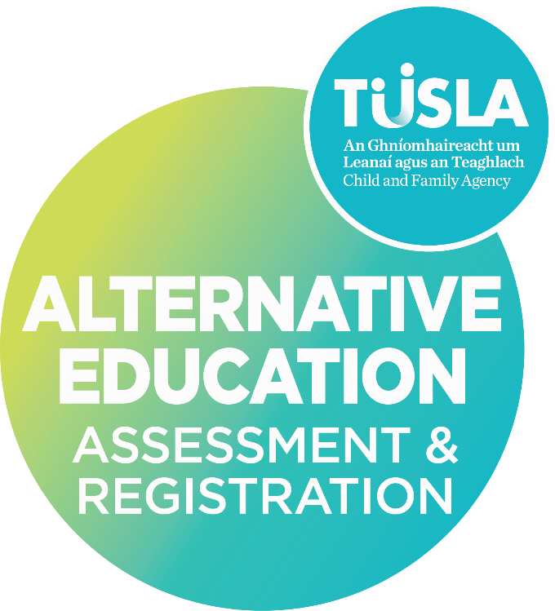
R2 SUPPLEMENTARY ENROLEMENT UPDATE
Information Form for an Independent School/Programme of Education - Enrolment Update During an Academic Year
For children in receipt of an education in a place other than a recognised school under Section 14 of the Education (Welfare) Act 2000.

[SCHOOL NAME] [Academic Year]
Date:

When to use an R2 Supplementary Enrolment Form

This R2 Enrolment Supplementary Form is to provide UPDATED information during an academic year and is used to supplement or update the information provided in the previously submitted R2 Enrolment Form. The information provided on this R2 Supplementary Enrolment List is used to amend the enrolment information provided on the R2 Enrolment List for children attending your school.

This form is not used to correct or amend enrolment information submitted. Where information has been omitted from an R2 Enrolment List submitted as part of an R2 Initial or Annual Update Form, this should be amended on the original R2 Enrolment Template and resubmitted.

If there are changes to the provision during an academic year that do not solely relate to the enrolment of children, such as a change of building, staff, governance, provision etc. this information along with any enrolment updates should be returned on a standard R2 Supplementary Form.

If you have additional updates to the premises, staff, or provision you will be required to submit a standard R2 Supplementary Information Form.

The R2 supplementary form should be returned to the Alternative Education Assessment and Registration Service by email independent.schools@tusla.ie

Guide to Completing the R2 Supplementary Enrolment List - Children Enrolled

What Children do I include on the R2 Enrolment List?

Under the Education (Welfare) Act, 2000 a child is a person resident in the State who has reached the age of six years and who—
- has not reached the age of 16 years, or
- has not completed three years of post-primary education
whichever occurs later, but shall not include a person who has reached the age of 18 years.

You are required to complete this form and the associated R2 Supplementary Enrolment Template for children who have
- Children who are over six years old and have not reached the age of 16 years that have joined your school during the academic year and were not included on a previous R2 Form
- Children who were previously enrolled at your school and have now turned 6 years/are due to turn 6 years¹
- Children that were identified as enrolled at your school for this academic year and who have left your school during the academic year

If a child is aged between 16-18 years and has not yet completed 3 years of post-primary education, their name should be included on the R2 Form and an R1 application should be submitted.

The Alternative Education Assessment and Registration Service cannot process applications for Section 14 Registration for children that do not come under the Education (Welfare) Act, 2000, nor can we store the data provided on an R2 Information Form.
- Please do not include the names of children under the age of six years on the R2 Enrolment Supplementary List Template (unless they are due to reach the age of 6 within 3 months of submitting the R2 Form).
- Please do not include children that have reached the age of 16 years on the R2 Enrolment List (unless they are newly enrolled and have not completed 3 years of post-primary education).

What information do I need to provide for children on the R2 Enrolment List?

You are required to provide the following information for children enrolled/due to be enrolled at your school for the current/upcoming academic year. Please insert additional rows onto the spreadsheet if required.

Children Enrolled – Tab 1
- First Name – where the child is known by another name, please include in brackets
- Surname – this should be the name on the child’s birth certificate and R1 application form
- Date of Birth – please include the date of birth for each child using the format DAY/MONTH/YEAR
- Age - the child’s age will be calculated automatically, and you are not required to enter data into this cell
- Class This School Year– Please use the dropdown menu to identify the class group for the current/upcoming academic year. If no class or group names are used, please select N/A.
- Other Class/Group Name – if you use an alternative class naming or grouping system please include details in this column.
- R1 Form Submitted with the R2 Form – please use the drop-down menu to confirm if the school is submitting an application on behalf of a parent for a child newly enrolled, recently turned/due to turn six, or for a child where an application has NOT previously been submitted.

Children Previously Enrolled – Tab 2
You are required to provide the following information for children that were enrolled at your school in the previous academic year and have not returned/will not be returning for the current/upcoming academic year. Please insert additional rows onto the spreadsheet if required.
- First Name – where the child is known by another name, please include in brackets
- Surname – this should be the name on the child’s birth certificate and R1 application form
- Date of Birth – please include the date of birth for each child using the format DAY/MONTH/YEAR
- Age - the child’s age will be calculated automatically, and you are not required to enter the age
- School Cycle Completed – Please identify if the child is leaving having completed the full cycle of the school provision or prior to completing the school cycle. This does not apply to children over the age of 16 years who were students at your school and who’s names will be automatically removed from the Section 14 Register.
- Information for Current Provision – please use the cell dropdown to identify the current provision for children who previously attended your school. You are not required to provide this information for children over the age of 16 years. If the child is now attending an independent school, please provide the school name. If the child is attending a Department of Education School, please provide the name and the address of the school. Where information is not provided by the parent(s)/guardian(s) please select Unknown from the dropdown menu.

Further information about Legislation, Registration, and Assessment can be found on the Alternative Education Assessment and Registration Service website

If you require any assistance to complete an R2 Information Form, please contact a member of the AEARS Independent School Team at independent.schools@tusla.ie or on 01-771 8649.

School Details

School Details
Name of School/Programme of Education | Click or tap here to enter text.  Click or tap here to enter text.
Principal Name
Person nominated to contact regarding the R2 Information Form

If any of the above details have changes since submitting the last R2 Information Form please contact the Alternative Education Assessment and Registration Service at independent.schools@tusla.ie

Update Children Enrolled

Number of Children Enrolled Update

Total Number for the Current/Upcoming Academic Year (Under Section 14 of the Education (Welfare) Act, 2000)
Please state the number of children currently enrolled at your school between the ages of 6-16 years.

Confirmation of Additional Names under section 14 of the Education (Welfare) Act, 2000, – New Enrolments during academic year/Children previously enrolled turned 6 years

Names of additional Children Enrolled
Please refer to Guidance Document before completing this section and the associated template provided
I confirm that I have provided the required information for new children enrolled at the school for the current academic year on Tab 1 of the Enrolment List Template provided  (*aged 6-16years, or up to 18 years if they have not completed 3 years post- primary education) | ☐ Yes

Confirmation of Names of children that have left the school during the academic year.

Names of Children Previously Enrolled that have left the school
Please refer to Guidance Document before completing this section and the associated template provided
I confirm that I have provided the required information on Tab 2 of the Enrolment List Template for children previously enrolled at the school who have left the school during this academic year | ☐ Yes  ☐ N/A

R2 Supplementary Form Completion – Checklist

The Principal/Person in Charge should complete the below checklist prior to signing the declaration
Parent(s)/guardian(s) of children newly enrolled at the school/turned 6 years have been informed of their obligations for children in receipt of an education in a place other than a recognised school, under Section 14 of the Education (Welfare) Act 2000. | ☐ Yes  ☐ No
If No – please provide additional information
I have submitted the names of children not previously provided to AEARS and the information for children that have left the school during the academic year on the Template provided | ☐ Yes  ☐ No
If No – please provide additional information
There are no further changes to the provision that I need to provide, and I understand that if I have any additional changes that these can be sent along with any updates on a standard R2 Supplementary Form | ☐ Yes
The Declaration is completed and signed by the principal/person in charge | ☐ Yes

Section 4. Principals Signed Declaration

I wish to submit the above information to the Child and Family Agency for the purpose of the registration of the above-named children under Section 14 of the Education (Welfare) Act 2000.

I declare: | ☐ That the children named on the Enrolment Form submitted for the current/upcoming academic year are pupils/students at this school.  ☐ That the details on this form are true and accurate to the best of my knowledge.  ☐ That the details of the education in place for these children is as provided to Tusla – Child and Family Agency.
I agree: | ☐ To inform the Agency if a child included on the enrolment list as part of this R2 form ceases to attend the school at any time during the academic year.  ☐ That I and the staff of this school will offer every assistance to an Authorised Person (Alternative Education Assessment and Registration Service Assessor) in conducting an assessment of the educational provision in place or proposed for the children.  ☐ To inform parent(s)/guardian(s) of the children identified as enrolled at this school that they are required under Section 14 of the Education (Welfare) Act 2000 to apply via an R1 application to Tusla – Child and Family Agency to have their child/children placed on the Section 14 Register (for children in receipt of an education in a place other than a recognised school).
I understand: | ☐ That in considering applications for registration, the Agency will arrange that an Authorised Person will conduct an assessment of the education in place or proposed for the children attending the school.  ☐ That the purpose of the assessment(s) will be to determine whether the educational provision in place or proposed for the children satisfies the requirements of a certain minimum education, in accordance with guidelines issued by the Minister for Education and by the Child and Family Agency.
Principal/Person in Charge
Signed: (please insert a copy of your scanned signature)

Date:

Principal/Person in Charge [Print Name]

QMS Reference | AEARS-FE16.3
Version | 1.0
Date | 07/10/2025

As there is a lead in time to processing an application and making a registration decision, children attending your school that due to turn 6 years within a 3 month period following the return of the R2 Form may be included in the enrolment list. The accompanying R1 applications can be submitted by the school on the parents behalf or by the parent directly to the service.

