
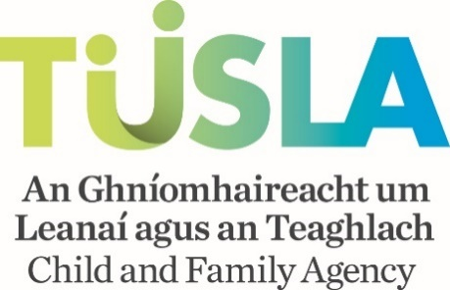
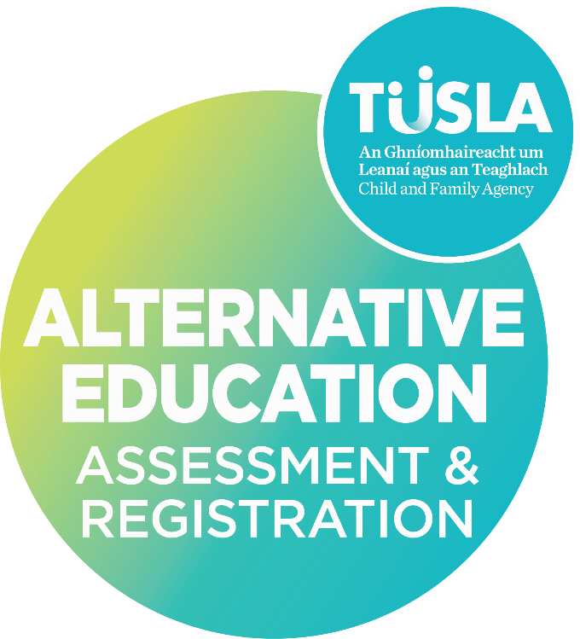
R2 Annual Update Information Form for an Independent School/Programme of Education
For children in receipt of an education in a place other than a recognised school under Section 14 of the Education (Welfare) Act 2000.

[SCHOOL NAME] [Academic Year]

Table of Contents

Section 1 - School Information 2
Section 1.1 General Information 2
Section 1.2 School Governance 3
Section 1.3 School Staff 4
Section 2 Safeguarding and Welfare 5
Section 2.1 – Garda Vetting 5
Section 2.2 – Child Protection and Welfare 5
Section 3 Premises and Safety 7
Section 3.1 – Premises 7
Section 3.2 – Water Supply 8
Section 3.3 – Health and Safety 9
Section 3.4 – Insurance Arrangements 9
Section 3.5 – First Aid 10
Section 3.6 – Fire Safety 10
Section 3.7 – Food Preparation 10
Section 4 Education Provision 11
Section 4.1 – Time Devoted to Education 11
Section 4.2 – Updated Information Educational Provision/Curriculum 12
Section 4.3 – Recording and Monitoring Progress 12
Section 5. Children Enrolled 13
Section 5.1 – Number of Children Enrolled 13
Section 5.2 – Confirmation of Names – Enrolment List 13
Section 6 R2 Form Completion – Checklist 14
Section 7 Principal’s Signed Declaration 15

Please ensure that all sections are completed as relevant and returned to the Alternative Education Assessment and Registration Service (no later than 4 weeks from the date of issue if operational or 2 weeks prior to opening)

Section 1 - School Information

Section 1.1 General Information
School Details
Full Name of School/Programme of Education | Click or tap here to enter text. | If known by another name | Click or tap here to enter text.
Address of School Premises |  | Administrative Address (if different)
Eircode | Click or tap here to enter text. | Telephone (include local code) | Click or tap here to enter text.
School mobile if available | Click or tap here to enter text. | E-mail | Click or tap here to enter text.
Person nominated to contact regarding the R2 Information Form | Name:  Role: | Contact Details for nominated person | Email:  Telephone:
School Type (tick all relevant boxes)
Primary | ☐ | Primary and Post Primary | ☐
Post Primary | ☐ | Transition Year Programme | ☐
Day School | ☐ | Boarding School | ☐
Total Number of Children Enrolled |  | Number of Children boarding at school
School Hours
No. of days school is in operation each year
Opening Time | Click or tap here to enter text. | Closing Time | Click or tap here to enter text.
Break 1 - Time | From:  To: | Break 2 – Time | From:  To:
Break 3 - Time | From:  To: | Break 4 - Time | From:  To:
Does the school provide a breakfast club or morning supervision | ☐ Yes  ☐ No | Hours of school breakfast club/morning supervision | From:  To:
Does the school provide an after-school service | ☐ Yes  ☐ No | Hours of after school service | From:  To:
Associated Services or Educational Provisions
Are other services provided by or within the school |  |  |  | ☐ Yes  ☐ No
If Yes – please provide details below

Section 1.2 School Governance
Management of School
Please state the name of the person or body that owns or manages the school |  | Name of contact person (e.g., chairperson, manager, managing director, etc.)
Email |  | Telephone: (include local code)
Postal Address

Eircode
Additional information relevant to the school’s governance (optional)

Section 1.3 School Staff
Principal/Person in Charge
* if the school operates with a management structure that does not include a principal, you should provide details for the person nominated to fulfil this role. The name of the person identified as the principal is responsible for the information provided on this R2 and should sign the declaration on this form.
Principal*  Name | Click or tap here to enter text. | Deputy Principal* Name | Click or tap here to enter text.
Groups/Classes taught if any |  | Groups/Classes taught if any | Click or tap here to enter text.
Contact Telephone number/s (include local code) |  | Contact Telephone number/s (include local code) | Click or tap here to enter text.
E-mail |  | E-mail | Click or tap here to enter text.
Staff Employed
Number of Full-Time Employed Teachers |  | Number of Part-Time Employed Teachers | Click or tap here to enter text.
Number of Full-Time Employed Auxiliary Staff |  | Number of Part-Time Employed Auxiliary Staff
Volunteers working/assisting at the School
Number of Full-Time Volunteers |  | Number of Part-Time Volunteers | Click or tap here to enter text.

Section 2 Safeguarding and Welfare

Section 2.1 – Garda Vetting
All staff must be Garda vetted in accordance with Part 3, Article 12 National Vetting Bureau (Children and Vulnerable Persons) Act 2012. The National Vetting Unit of An Garda Síochána should be contacted in relation to all matters regarding vetting of staff employed at your school. Please refer to the R2 Information Form Guidelines for information.
I declare that all staff have been Garda vetted (see guidelines for further information). | Click or tap here to enter text.  ☐ Yes
I declare that all staff have been police vetted where applicable (see guidelines for further information). | ☐ Yes
I declare that all volunteers have been Garda vetted, and police vetted where applicable (see guidelines for further information). | ☐ Yes  ☐ N/A
Persons working with children must be Garda Vetted. Where staff /volunteers have not yet been Garda Vetted, they must not have direct contact working with children.

If any staff and/or volunteers have not been Garda/(Police) vetted, please provide reasons why below -
I declare that all staff prior to commencement of work in the school/organisation have been appropriately vetted by the receipt and verification of references from previous employment? | ☐ Yes  ☐ No
If staff have not been appropriately vetted by the receipt and verification of references from previous employment, please provide reasons why.

Section 2.2 – Child Protection and Welfare
Please refer to the R2 guidance document for further information on Child Protection and Welfare
The school has a Child Safeguarding Statement as required by part (11) Children First Act 2015 | ☐ Yes  ☐ No
If Yes – has the Child Safeguarding Statement been confirmed compliant by the Tusla Child Safeguarding Statement Compliance Unit (CSSCU)? | ☐ Yes  ☐ No
I have submitted a copy of the Child Safeguarding Statement currently in use with this R2 form | ☐ Yes  ☐ No
The procedures below as identified in the Child Safeguarding Statement are in place and implemented at my school  - Procedure for the management of allegations of abuse or misconduct against workers/volunteers of a child availing of our service  - Procedure for the safe recruitment and selection of workers and volunteers to work with children  - Procedure for provision of and access to child safeguarding training and information, including the identification of the occurrence of harm  - Procedure for the reporting of child protection or welfare concerns to Tusla  - Procedure for maintaining a list of the persons (if any) in the relevant service who are mandated Persons  - Procedure for appointing a relevant person  All procedures listed are available upon request. | ☐ Yes ☐No  ☐Yes ☐No  ☐Yes ☐No  ☐Yes ☐No  ☐Yes ☐No  ☐Yes ☐No  ☐Yes ☐No
All staff and volunteers have been trained in the implementation of the school’s Child Safeguarding Statement | ☐ Yes  ☐ No
All staff and volunteers have been trained in Children’s First Guidelines 2017 | ☐ Yes  ☐ No
If you ticked No for any of the above requirements for child safeguarding, please provide details below.
The Alternative Education Assessment and Registration Service support independent schools to ensure they meet requirements under the Childre’s First At 2015.

Section 3 Premises and Safety

Section 3.1 – Premises
Section 3.1 should only be completed if there have been changes to your premises in the last 12 months or your premises are due to change in the coming 12 months.
Change to Premises
We have changed/are planning to change premises | ☐ Yes
If Yes – Date of move to new premises

If Yes – The address of the new premises

The premises the school is using/planning to use is
☐ A Domestic Dwelling
☐ A Purpose Build
☐ A Refurbished/Change of Use of an Existing Building
☐ Located in a building where activities other than education take place
We have modified/are planning to modify our premises | ☐ Yes
If Yes – Date of modifications to premises

If Yes – have you reviewed how any modification to the premises may impact on fire safety and ensured that fire safety policy and procedures have been amended accordingly. | ☐ Yes
Please outline details of modifications planned or completed
If you have moved or modified your building please confirm that the new school building has a Certificate of Planning Permission | ☐ Yes  ☐ No
If no certificate of planning permission is in place, please state the reasons why
If the school is located in a building where activities other than education take place, please specify the nature of those activities
Please give details of the outdoor play area including size and recreational facilities available to children

Section 3.2 – Water Supply
Water Supply
The premises water supply is | ☐ A Private Well  ☐ A group water scheme  ☐ Connected to main water supply
If using a private well or a group water scheme, please state when it was last tested for contamination

Section 3.3 – Health and Safety
Health and Safety
The school has a safety statement under the Health and Safety Act 2005 | ☐ Yes  ☐ No | Copy of Health and Safety Statement submitted | ☐ Yes  ☐ No
School personnel have been provided with training in Health and Safety and have been provided with a copy of the Health and Safety Statement | ☐ Yes  ☐ No
If you have ticked No to any of the above statements, please provide details below.

Section 3.4 – Insurance Arrangements
Insurance Arrangements
The school is adequately insured accident, injury or untoward incident. | ☐ Yes  ☐ No
If No - please provide additional information below
If Yes - please provide information for: | The number of children covered:
If Yes - please provide information for: | The date of insurance cover:
If Yes - please provide information for: | Name and address of insurance company/broker:
I have provided confirmation in writing from the insurance company/broker with this form. | ☐ Yes  ☐ No

Section 3.5 – First Aid
First Aid
Please state the number of staff that have up to date first aid training
Please state arrangements for storage and administration of medication

Section 3.6 – Fire Safety
Fire Safety (Fire Services Act 1981)
Please provide details of Fire Safety Policies including fire drills, upkeep of fire supressing equipment, training of staff.
The premises has a fire safety and compliance certificate as required by building and planning regulations | ☐ Yes  ☐ No
If No, please state the reasons why
I confirm that a copy of the fire safety and compliance certificate has been submitted with this form | ☐ Yes  ☐ No

Section 3.7 – Food Preparation
Food Preparation
Do you prepare, serve, and store food for consumption by pupils | ☐ Yes  ☐ No
If Yes, please outline the arrangements for preparation, storage, and serving of food
If Yes, has the school notified the HSE of food preparation onsite | ☐ Yes  ☐ No
If you have not notified the HSE of food preparation onsite, please provide reasons why

Section 4 Education Provision
Assessment of Provision
As part of the registration process, the provision at the school is subject to assessment. An assessment of the education that is in place or proposed for the children will be carried out by arrangement by The Alternative Education Assessment and Registration Service - Tusla Child and Family Agency The assessment will be carried out by an Authorised Person appointed by the Agency. Please refer to the R2 Information Form Guidance document for further information.

Section 4.1 – Time Devoted to Education
School Days Operational for Current/Upcoming Academic Year
A copy of the school calendar for the current/upcoming academic year has been submitted with this form | ☐ Yes  ☐ No
If No - please list periods during which school will be in operation for the current/upcoming school year.
A copy of the school timetable for the current/upcoming academic year has been submitted with this form | ☐ Yes  ☐ No
If No - please state the amount/proposed amount of time devoted to each area of learning during each week.

Section 4.2 – Updated Information Educational Provision/Curriculum
Please provide information regarding any updates or changes to the educational provision in the school
School Curriculum
The school has implemented or plans to make a change to the educational provision for the current academic year. | ☐ Yes  ☐ No

If Yes – please provide a brief outline below of the changes or proposed changes to the provision for each of the groups/classes.

Section 4.3 – Recording and Monitoring Progress
Record Keeping and Monitoring Progress
The school has mechanisms to record each child’s educational progress | ☐ Yes  ☐ No
If Yes – please briefly outline details of any records being maintained of the child’s progress
The school has mechanisms to assess and monitor each child’s educational progress | ☐ Yes  ☐ No
If Yes – please briefly outline details of how progress is assessed and monitored is carried out

Section 5. Children Enrolled

Section 5.1 – Number of Children Enrolled
Total Number for the Current/Upcoming Academic Year (Under Section 14 of the Education (Welfare) Act, 2000)
Please state the number of children enrolled at your school between the ages of 6-16years
The school enrols children under the age of 6 years | ☐ Yes  ☐ No
If Yes – please state the number of children enrolled under the age of 6 years
The school enrols children over 16 years | ☐ Yes  ☐ No
If Yes – please state the number of children enrolled over the age of 16
If Yes – please state the number of children enrolled over the age of 16 who have not completed 3 years post primary education

Section 5.2 – Confirmation of Names – Enrolment List
Names of children enrolled and children who have left the school
Please refer to Guidance Document before completing this section and the associated template provided
I confirm that I have provided information of *ALL children enrolled and previously enrolled at the school for the current/upcoming academic year on the Enrolment List Template provided  (*aged 6-16years, or up to 18 years if they have not completed 3 years post- primary education) | ☐ Yes
I confirm that if a child is newly enrolled* at the school during the current/upcoming academic year, I will submit the required information to the Alternative Education Assessment and Registration Service using the R2 Form provided.  *between the age of 6 and 16 years (and between 16 years and 18 years if they have NOT completed 3 years post primary education). | ☐ Yes
I confirm that if a child reaches the age of 6 years and comes under the Education (Welfare) Act, 2000 I will submit the required information to the Alternative Education Assessment and Registration Service using the R2 Form provided. | ☐ Yes  ☐ N/A

Section 6 R2 Form Completion – Checklist
The Principal/Person in Charge should complete the below checklist prior to signing the declaration
Parent(s)/guardian(s) of children enrolled at the school have been/will be informed of their obligations for children in receipt of an education in a place other than a recognised school, under Section 14 of the Education (Welfare) Act 2000. | ☐ Yes  ☐ No
If No – please provide additional information
I have submitted the associated documents as requested, please tick items below as relevant
☐ Child Safeguarding Statement required by part (11) Children First Act 2015
☐ Certificate of Planning Permission (if relevant)
☐ Health and Safety Statement under the Health and Safety Act
☐ Insurance documentation in relation to the school and the cover of students
☐ Fire safety and compliance certificate
I have submitted An Enrolment List on the Template provided | ☐ Yes  ☐ No
If No – please provide additional information below
The Declaration is completed and signed by the principal/person in charge | ☐ Yes

Section 7 Principal’s Signed Declaration
I wish to submit the above information to the Child and Family Agency for the purpose of the registration of the above named children under Section 14 of the Education (Welfare) Act 2000.

I declare: | ☐ That children named on the Enrolment Form submitted for the current/upcoming academic year are pupils/students at this school.  ☐ That details on this form are true and accurate to the best of my knowledge.  ☐ That details of the education in place for children is as provided to Tusla – Child and Family Agency.
I agree: | ☐ To inform the Agency if a child included on the enrolment list as part of this R2 form ceases to attend the school at any time during the academic year.  ☐ That I and the staff of this school will offer every assistance to an Authorised Person (Alternative Education Assessment and Registration Service Assessor) in conducting an assessment of the educational provision in place or proposed for the children.  ☐ To inform parent(s)/guardian(s) of the children identified as enrolled at this school that they are required under Section 14 of the Education (Welfare) Act 2000 to apply via an R1 application to Tusla – Child and Family Agency to have their child/children placed on the Section 14 Register (for children in receipt of an education in a place other than a recognised school).
I understand: | ☐ That in considering applications for registration, the Agency will arrange that an Authorised Person will conduct an assessment of the education in place or proposed for the children attending the school.  ☐ That the purpose of the assessment(s) will be to determine whether the educational provision in place or proposed for the children satisfies the requirements of a certain minimum education, in accordance with guidelines issued by the Minister for Education and by the Child and Family Agency.
Principal/Person in Charge
Signed: (please insert a copy/photo of your scanned signature)

Date:

Principal/Person in Charge [Print Name]

QMS Reference | AEARS-FE16.2
Version | 1.0
Date | 07/10/2025

