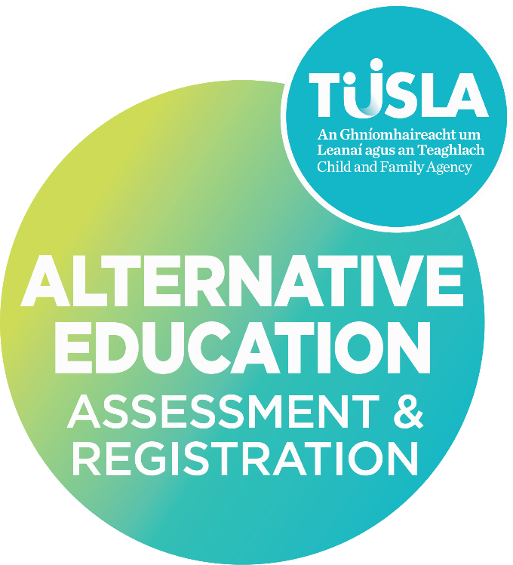

|  |  |
| --- | --- |
| QMS Reference | AEARS-FE01.1 |
| Version | 3.0 |
| Date | 04/03/2025 |

**Application for registration of children receiving education in a place other than a recognised school Section 14 of the Education (Welfare) Act 2000 (R1)**

## Application Form Part A

|  |  |
| --- | --- |
| **Place where child will receive the education** | |
| Independent School or Centre of Education setting; |  |
| Their home |  |
| Their home and another setting |  |

**PART A**

|  |  |  |  |
| --- | --- | --- | --- |
| 1. **Details of child** | | | |
| Surname (as on birth cert) |  | First name(s) (as on birth cert) | Click or tap here to enter text. |
| Date of birth |  | Gender (optional) | Click or tap here to enter text. |
| Home address | Click or tap here to enter text. | Eircode | Click or tap here to enter text. |
| PPSN | Click or tap here to enter text. |  |  |

|  |
| --- |
| **2) Details of Parent(s)/Guardian(s)** |
| Throughout this document the term ‘‘parent,’’ in line with the use of the word in the Education Act 1998, section 2 and the Education (Welfare) Act 2000, should be taken to mean parent, guardian, foster-parent, a person acting in loco parentis who has a child in his/her care subject to any statutory power or court order, or a person who has adopted a child. |

|  |  |  |  |
| --- | --- | --- | --- |
| **Parent/Legal Guardian 1** | | | |
| Title | Click or tap here to enter text. | First name(s) | Click or tap here to enter text. |
| Surname |  | Home address (if different to above) |  |
| Eircode | Click or tap here to enter text. | Telephone (include local code) | Click or tap here to enter text. |
| Mobile | Click or tap here to enter text. | E-mail | Click or tap here to enter text. |
| **Parent/Legal Guardian 2** | | | |
| Title | Click or tap here to enter text. | First name(s) | Click or tap here to enter text. |
| Surname | Click or tap here to enter text. | Home address (if different to above) | Click or tap here to enter text. |
| Eircode | Click or tap here to enter text. | Telephone (include local code) | Click or tap here to enter text. |
| Mobile | Click or tap here to enter text. | E-mail | Click or tap here to enter text. |

|  |  |  |  |
| --- | --- | --- | --- |
| **Details of guardian(s)/foster parent(s) (if appropriate)** | | | |
| Surname | Click or tap here to enter text. | First name(s) | Click or tap here to enter text. |
| Relationship to Child | Click or tap here to enter text. | Home address (if different to above) | Click or tap here to enter text. |
| Eircode | Click or tap here to enter text. | Telephone (include local code) | Click or tap here to enter text. |
| Mobile | Click or tap here to enter text. | E-mail | Click or tap here to enter text. |

|  |  |  |
| --- | --- | --- |
| **Additional Information** | | |
| Have you previously applied to the Section 14 Register for this child? | Yes | No |
| Are any sibling(s) of this child currently on the Section 14 Register, or  have you applied for any sibling(s) of this child? | Yes | No |
| If yes, please supply details: | | |
| Click or tap here to enter text. | | |

|  |  |  |
| --- | --- | --- |
| **Previous education history -** *Please tick one of the following* | | |
| New application for child that has recently turned 6 years old. | |  |
| Previously home educated | |  |
| Dates of home education: | Click or tap here to enter text. | |
| Previously educated in a school (Department of Education recognised school, an Independent School or school in another jurisdiction) | |  |

|  |  |  |  |  |
| --- | --- | --- | --- | --- |
| *If the child has attended any school(s) please give details of the last school attended* | | | | |
| Full name of school |  | Address | Click or tap here to enter text. | |
| Principal | Click or tap here to enter text. |
| Telephone (include local code) | Click or tap here to enter text. | Email | Click or tap here to enter text. | |
| Date child was enrolled in the school, and year level (if applicable). | | Click or tap here to enter text. | | |
| Date on which child left the school, and year level (if applicable). | | Click or tap here to enter text. | | |
| Has child competed 3 years’ post-primary education? | | Yes | | No |

|  |  |  |
| --- | --- | --- |
| **6) Additional Learning and Support Needs** | | |
| Does your child have any learning needs or additional support needs? | Yes | No |
| If yes, outline summary of need below: | | |
| Click or tap here to enter text. | | |
| Has the learning/support need been formally assessed? Is the child currently engaged with support services currently? Please provide details. | | |
| Click or tap here to enter text. | | |

|  |
| --- |
| **7) Location where the delivery of the education will occur** |
| Please complete the relevant section. |

|  |  |  |  |
| --- | --- | --- | --- |
| **a) Independent School or Centre of Education** | | | |
| *Please provide the details of the school providing or planned to provide the delivery of the education provision.* | | | |
| Independent School Name | Click or tap here to enter text. | Postal address | Click or tap here to enter text. |
| Principal/Director | Click or tap here to enter text. |
| Telephone (include local code) | Click or tap here to enter text. | Eircode | Click or tap here to enter text. |
| E-mail | Click or tap here to enter text. | Mobile |  |
| Date child commenced/due to commence at school | | Click or tap here to enter text. | |
| Date child due to leave school | | Click or tap here to enter text. | |

|  |  |  |  |
| --- | --- | --- | --- |
| **b) Home Education** | | | |
| *Please provide the address of the location where the education will be provided. Please include details of the person/s who will be providing the delivery of the education provision.* | | | |
| Address: | Click or tap here to enter text. | | |
| **Person 1 – Education Provider** | | | |
| Title | Click or tap here to enter text. | First name(s) | Click or tap here to enter text. |
| Surname | Click or tap here to enter text. | Telephone (include local code) | Click or tap here to enter text. |
| Mobile | Click or tap here to enter text. | E-mail | Click or tap here to enter text. |
| Relationship to child | Click or tap here to enter text. |  |  |
| **Person 2 if applicable** | | | |
| Title | Click or tap here to enter text. | First name(s) | Click or tap here to enter text. |
| Surname | Click or tap here to enter text. | Telephone (include local code) | Click or tap here to enter text. |
| Mobile | Click or tap here to enter text. | E-mail | Click or tap here to enter text. |
| Relationship to child | Click or tap here to enter text. |  |  |

|  |  |  |  |
| --- | --- | --- | --- |
| **c) Online Education programme (accessed in the child’s home or in another location)** | | | |
| *Please provide the address of the location where the education will be provided. Please include details of the person/s who will be providing the delivery of the education provision.* | | | |
| Address(es) where the child accesses the online education programme: | Click or tap here to enter text. | | |
| Name and location of education provider: | Click or tap here to enter text. | | |
| Webpage if applicable: | Click or tap here to enter text.  Click or tap here to enter text. | | |
| Number of hours per week that the child will be registered for tuition: | Click or tap here to enter text. |  |  |

## Application Form Part B

**Home Education Applicants** **Only**

|  |
| --- |
| **8. 8. Time devoted to education of child / Time proposed to be spent on education of child** |
| *The informal or semi-informal nature of home-based education may make it difficult to estimate accurately the amount of time allocated to learning. Information under the headings below may be useful in establishing a general pattern of the educational provision.*   * *the time allocated/to be allocated to the education of the child.* * *whether learning is provided for in an open-ended manner, or whether learning activities are scheduled, or partly scheduled, using a timetable following a daily/weekly/monthly patter.* * *the estimated number of days during the year on which education is/will be provided.* * *if any records are/will be maintained of the time/periods/days devoted to education.* * *where child is engaged in an online programme, as detailed under 7(c) above, estimate the number of hours per day the child will engage in online education.* |
| Click or tap here to enter text. |

|  |
| --- |
| **9. Equipment and materials** |
| *Please provide brief details of some of the main items/publications/materials used to support the child’s learning. These may include curriculum documents, specialised educational equipment, reference materials/textbooks, or everyday objects and materials including books, magazines, toys, videos etc.* |
|  |

|  |
| --- |
| **10. Educational Activities** |
| *Give a brief account of the educational provision made / to be made for the child’s learning including:*   * *Provision for the development of literacy and numeracy skills; physical skills; social, emotional and moral.* * *What are the main areas of learning for which provision is/will be made?* * *What type of education is being/will be provided? Do any particular principles or philosophies inform the education?* * *What approaches or methods are/will be used to facilitate learning? (e.g. autonomous learning, semi-structured approaches, structured learning, a mixture of these)* * *If the education provided is based on any published curricula or learning programmes, please give details.* |
| Click or tap here to enter text. |
| ***NOTE****: Meeting the requirements of a ‘certain minimum education’ does not mean that a child must follow any particular curriculum delivered in a school setting. However, if a child were to return to a formal school-based education at primary or post-primary level at any stage, parents/guardians, in planning a home education programme for their children, should be conscious of the curriculum requirements, and teaching and learning structures to which they may return.* |

|  |
| --- |
| **11. Monitoring progress** |
| *Please give a brief account of how the child’s progress is/will be monitored. Some points to consider may be:*   * *How is/will the child’s progress be monitored/assessed?* * *Are/will any records be maintained of the child’s progress?* * *What considerations has been given to how the learning needs of the child are/will be met over a period of time and whether plans are/will be recorded?* |
|  |

|  |  |
| --- | --- |
| **12. Declaration**  Please read carefully.  The deliberate provision of false or misleading information or statements in support of this application will render the application invalid. If it later comes to the attention of the agency that your child was placed on the register on the premise of false or incorrect information, your child’s name may be removed from the register. | |
| **I/We declare that:**   * *The information provided on this application form is true and accurate.* * *That both legal guardians where applicable have provided their personal details and contact information and have signed this application form.*   **I/We understand:**   * *That in considering this application for registration, the Agency will arrange for an assessment to determine whether the education provision in place or proposed for the child, satisfies the requirements of a certain minimum education [s.14(5)(a,b,c) Education (Welfare) Act 2000].*   *Pursuant to Part 2, Section 9 (4) of the Child and Family Agency Act, 2013 the assessor will speak to your child in order to ascertain their views as part of the assessment process.*   * *That in order to ensure that the child continues to receive a “certain minimum education”, the Agency will carry out further assessments, and these assessments will be notified in advance [s.14 (7) Education (Welfare) Act 2000].* * *That if, on receipt of the assessment report, the agency is unable to determine that a certain minimum education is being provided or likely to be provided, the agency may proceed to a further assessment [s.14(5)(i,ii,iii) Education (Welfare) Act 2000].* * *That all assessment(s) will be conducted in accordance with any guidelines issued under Section 14,15 and 16 of the Education Welfare Act 2000.* * *That I/We will offer every assistance to an authorised person (assessor) in assessing the education provision in place or proposed for the child.*   **I/We consent:**   * *For the Agency to have an authorised person conduct assessment(s) of the education in place or proposed for the child who is the subject of this application.* * *For the Agency to verify any information provided on this application form.*   **I/We have enclosed a certified copy of the child’s birth certificate or passport**  Yes | |
| Signature of Guardian 1: |  |
| Date: |  |
| Signature of Guardian 2: |  |
| Date: |  |
| *All legal guardians must sign this form in order for the application to be processed.* | |
| **Tá leagan Gaeilge den fhoirm se oar fail ach é a iarraidh.** | |
| Registration of children receiving education in places other than a recognised school under Section 14 of the Education (Welfare) Act 2000. | |

## 