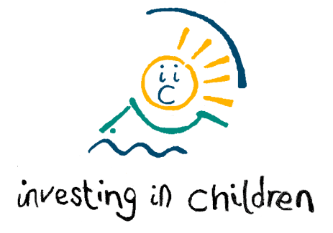
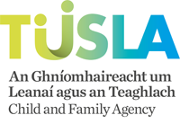
Investing in Children Membership Award™
Information Sheet
Name of Service

Name of Lead Contact
(Correspondence i.e. Principal/Manager/Team Leader)
Name of Key Contact
(who is responsible for liaising with the assessor)
Address

Telephone

Contact email
Facebook & Twitter page

Website
How did you hear about Investing in Children?

What name do you want to appear on the IiC Membership Award certificate?

How many children and young people are involved in your service?

How many children and young people will be involved in the evaluation process?

Age of children and young people involved in your school?

Preferred assessment time (i.e. AM/PM/after 4pm etc)

Please complete Information sheet and return to: West: Jacqueline.Concannon@tusla.ie
South: amy.hayes2@tusla.ie DML: avril.dooley1@hse.ie DNE: mary.ferris@tusla.ie

This is for Admin purposes – please do not fill in

Summary of Project:

Admin:

Membership Report History
Date Completed | Worker | Certificate  Sent | Date Completed | Worker | Certificate  Sent

Project Breakdown
Service |  | Number of C&YP
Department |  | Ages
Unit |  | Area

Updated

Expectations
What you can expect from us once you achieve Investing in Children Membership Award™?
Most organisations decide with their children and young people how to celebrate achieving the Investing in Children Membership Award™.
Investing in Children will:
- Give recognition for your achievement by sharing your good practice in the Investing in Children newsletter
- Supply you with the Investing in Children logo which you can use on letterheads, websites and publicity materials.
- Your organisation could be used as a case study in the Investing in Children Training Programme.
- Your good practice might be used as an example to share with similar organisations, and exchange visits might be arranged to show what can be achieved.
As an organisation/project you will be entitled to use your Membership Award™ for your own purposes e.g. as evidence for extended inspections or in grant applications.

“We as children and young people are reassured when we visit somewhere and see an Investing in Children certificate that there will be someone there who actually listens to you and you will be able to put forward ideas.” Quote from the young people involved in this process.

What we expect from you:
- Membership lasts for one year. We will write to you before the end of the year to remind you that your renewal date is near, in order for you to prepare your evidence for re-evaluation. Once your evidence is returned Investing in Children will then contact you to make a date.
- Investing in Children Memberships are expected to renew within 6 months of the renewal date (exceptions will be made if services are in discussion with IIC). Services will be transferred to the application list if not successfully re-evaluated within 2 years.

Investing in Children CIC
Website: www.investinginchildren.net
We are a Community Interest Company (registered in England & Wales) No. 8428687
Investing in Children Membership Award™ is a registered Trademark™.
Follow us on Facebook | Follow us on Twitter: @IiC_rights
Like and Share our Facebook & Twitter pages!  

