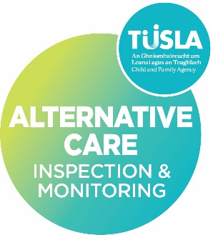
ACIMS-FE11.2
V1.0
02/06/2026

Director/Board Member Declaration Regarding Garda Vetting

The Child Care Act 1991, Part VIII section 59 defines a registered proprietor in relation to a registered children's residential centre, means the person whose name is entered in the register as the person carrying on the centre. As the registered proprietor you have a legal responsibility to comply with the Child Care (Standards in Children’s Residential Centres) 1996. The Child Care Act 1991, Part VIII Section 63 (3) (a) states; where, in relation to a centre, there is a failure or refusal to comply with a provision of the regulations, the registered proprietor and the person in charge of the centre shall be guilty of an offence.
As part of the application to register a centre the Alternative Care Inspection and Monitoring Service require up to date information and Garda vetting for all registered proprietor(s), Board Members or Directors. In the event that you are unable to attain Garda Vetting due to your role or title the ACIMS request you complete this declaration.

I, _______________________________ (Name), in my role as ____________ (position) of _______________ (organisation), hereby declare the following:

Role and Contact with Children
I confirm that I do not undertake relevant work or activities, as defined under the National Vetting Bureau (Children and Vulnerable Persons) Acts 2012-2016, and that a necessary and regular part of my role does not involve direct access to, or contact with, children.

My role is limited to governance, strategic oversight, and corporate/director responsibilities and does not include operational involvement in the day-to-day delivery of services to children.

Safeguarding Responsibilities
Notwithstanding the above, I acknowledge my responsibilities under:
- The Child Care Act, 1991
- The Children First Act, 2015
- All applicable statutory requirements and National Standards
To ensure that:
- Effective safeguarding arrangements are in place,
- Policies and procedures are implemented and reviewed
- Appropriate governance and oversight systems are maintained
- The welfare and protection of children remains paramount at all times.

Governance and Oversight Arrangements
I confirm that appropriate governance structures are in place to ensure compliance with regulatory frameworks, statutory requirements and applicable National Standards.

Operational oversight of the service has been assigned to _______________ (name), _____________(role), who is responsible for:
- Monitoring regulatory compliance
- Implementation and oversight of safeguarding procedures
- Quality assurance and risk management
- Oversight of service delivery

The Board/Director(s) retain overall governance accountability for the organisation and receive ongoing reports and assurances regarding the operation and safeguarding of the service.

Declaration
I confirm that the information contained within this declaration is true and accurate and reflects the governance arrangements currently in place within the organisation.

Signature: __________________________________

Name (Print): _______________________________ Date:
Director/Board Member

